THE NORTHEAST OF THE USA

1. Please find out the names of the nine states.
1.
2.
3.
4.
5.
6.
7.
8.
9.

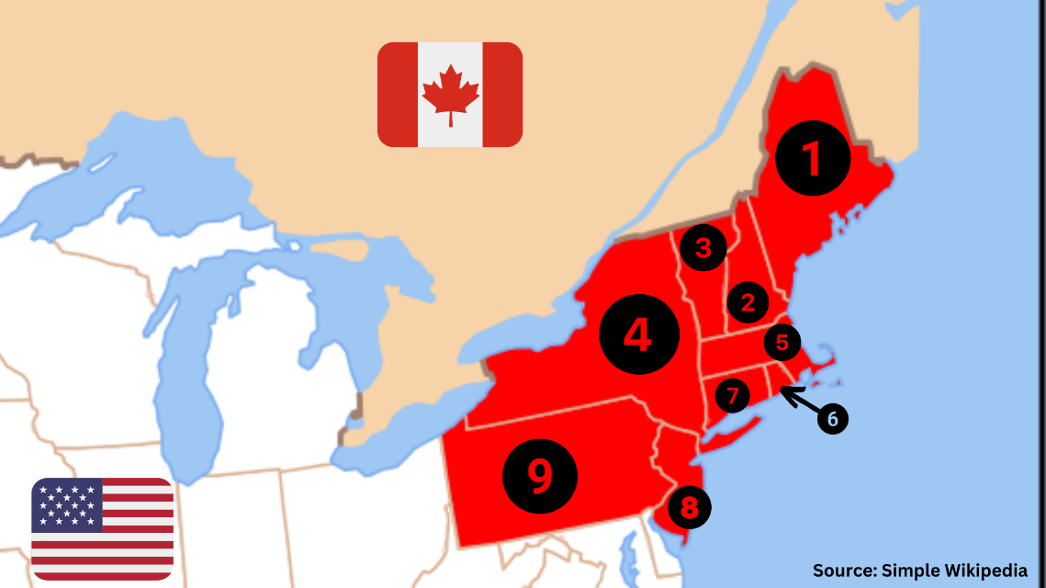

2. Please fill out your state profile.

MY STATE
Nickname
Inhabitants
Capital
Interesting places
and sights
State bird
State flower

3. Make a crossword about your state. Use a minimum of ten words.

My words: ___________________________________________________________________________
_______________________________________________________________________________________

4. Please write ten sentences about the Northeast of the United States of America.
1
2
3
4
5
6
7
8
9
10

