Form: ________ Date: ______________ 20__ Name: _____________________________________

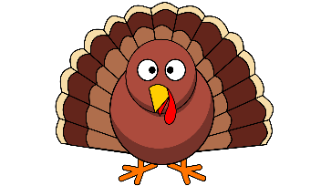

THANKSGIVING

Americans celebrate Thanksgiving on the ________ __________ of ________________. Schools and shops close for ________ days. It is a special day for ________________, and people travel to see their friends and families. There always is a lot of traffic on the road.
The Thanksgiving tradition started with the “__________ Fathers”. They were settlers and the founders of a colony in North _______________. The Pilgrims were against the Church of ____________, and they wanted to start a new life. So, on 6th September _______, 102 men, women and children left England in a ship called _______________. The trip was not easy, but the Pilgrims arrived in America on 11th ___________ 1620. They landed on the north-west coast of America and called the place _____________. It was winter, and there was not much food. So, the settlers built small houses, but it was too late to grow anything. The winter was long and a lot of people ________.
Luckily, the Native _____________ helped the Pilgrims and showed them how to grow _________ and how to __________. Soon, the Pilgrims and the Native Americans became good _____________. The Pilgrims grew crops and the harvest was great. By November ______, everybody had food and a home. So, the Pilgrims decided to celebrate the event with a big ___________ because they wanted to thank God. That was the first Thanksgiving dinner.
Today, the traditional Thanksgiving meal is similar to the first. People eat _________ ________ with cranberry sauce, __________, and __________ pie. Many people and a lot of organisations prepare a free meal for __________ people in their towns or cities.
In ____________________ (city), there are also famous parades and more than two million people watch the parades every year.
All in all, people celebrate Thanksgiving because they are ________________ for the things they have in their lives. Many are thankful for their friends, their _________________, and their food.

Sources: https://en.islcollective.com/ https://www.britannica.com/topic/Thanksgiving-Day

