How to sound like an Aussie
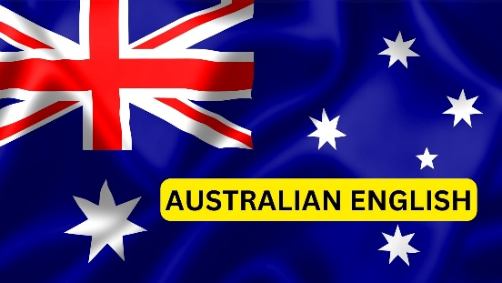
 | Australian English | Meaning | Information / Example

1

2

3

4

5

6

7

8

Sources: Canva / www.fluentu.com (2023)

